Abstract
Modern urban environments demand intelligent systems capable of navigating complex public spaces with minimal human intervention. Routine operations such as waste collection, surveillance, and last-mile delivery often face challenges related to traffic congestion, safety risks, and dependency on manual labor. To address these gaps, this project proposes a PID-Controlled Autonomous Line-Following and Obstacle-Avoiding Robot designed for smart public road infrastructure. The robot integrates PID-based path correction, ultrasonic obstacle detection, and Bluetooth-enabled communication, enabling real-time adaptive navigation across dynamic environments. Through sensor fusion and intelligent control logic, the system provides a compact, energy-efficient, and scalable solution that supports safer, faster, and more sustainable mobility. The prototype demonstrates clear potential for enhancing smart city operations, reducing human error, and improving overall transportation efficiency.
Introduction
With rapid urbanization and rising vehicle density, modern cities face increased challenges in maintaining safe, efficient, and sustainable mobility solutions. Traditional transportation and utility systems rely heavily on human involvement and lack the adaptability required to respond to dynamic obstacles and unpredictable road conditions. As a result, issues such as traffic congestion, delayed services, and safety hazards persist—contributing to over 1.3 million global road accidents annually, many caused by slow human response to obstacles.
The advancement of autonomous robotic systems presents a transformative opportunity for improving urban infrastructure. Autonomous line-following and obstacle-avoiding robots can support critical operations such as navigation, monitoring, waste collection, and last-mile delivery, significantly reducing manual effort and enhancing operational accuracy.
This project introduces a multi-sensor autonomous robot driven by PID control for smooth and precise path tracking, combined with real-time obstacle avoidance using ultrasonic sensing. The robot also features smart communication capabilities for remote monitoring and manual override, making it a versatile solution for smart mobility ecosystems. By leveraging modular hardware design and intelligent algorithms, this system aligns with the long-term vision of smart cities—ensuring safer streets, efficient transport operations, and improved public service delivery
List of components
- Microcontroller (Arduino ATmega2560)
- IR sensor module
- Ultrasonic sensor
- L298 Motor driver module
- Bot wheels
- Chassis
- 12V battery
- Castor wheel
- Breadboard
- Jumper wire
- Switch
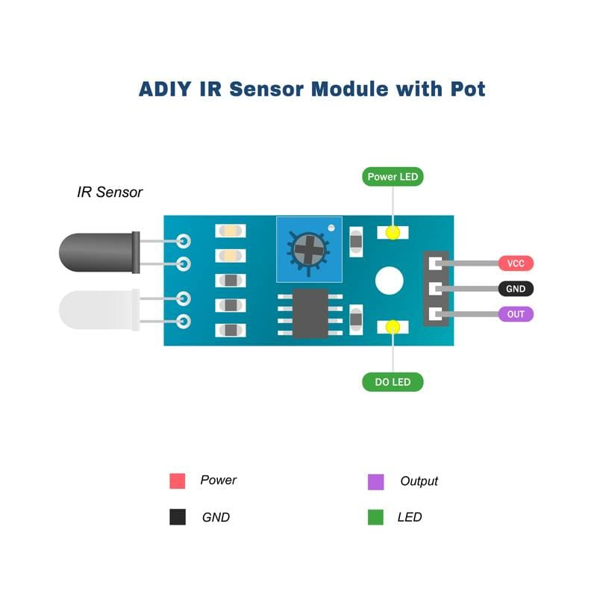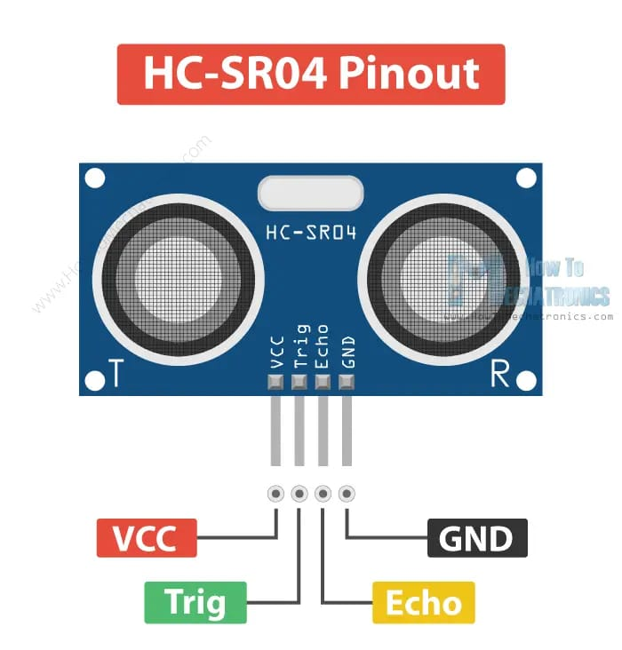
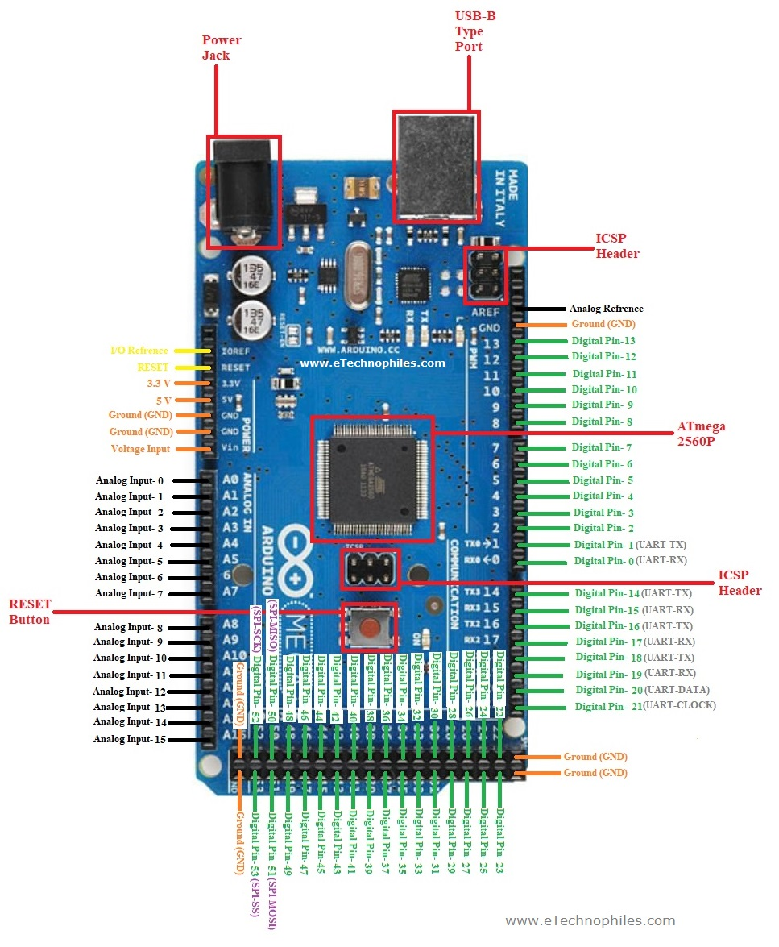
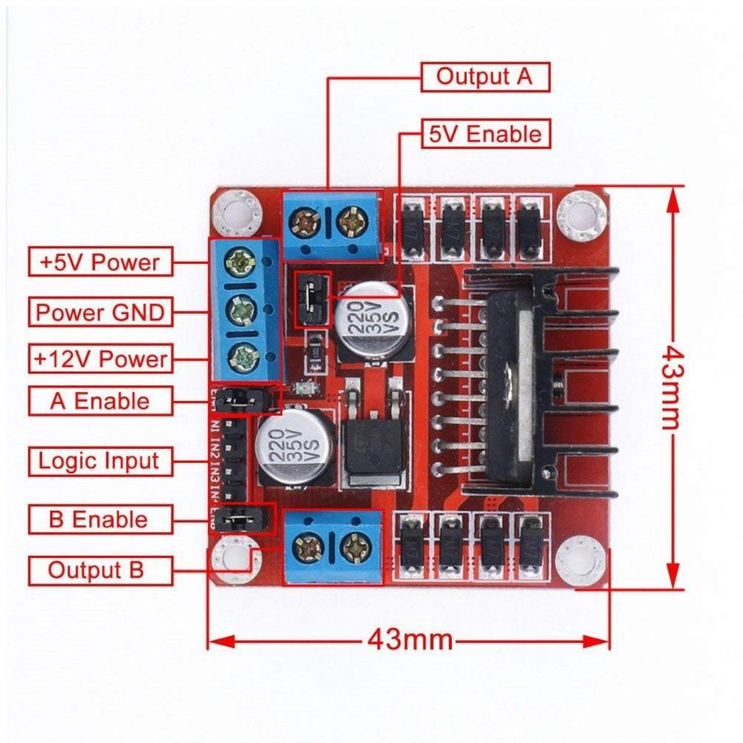
Connection diagram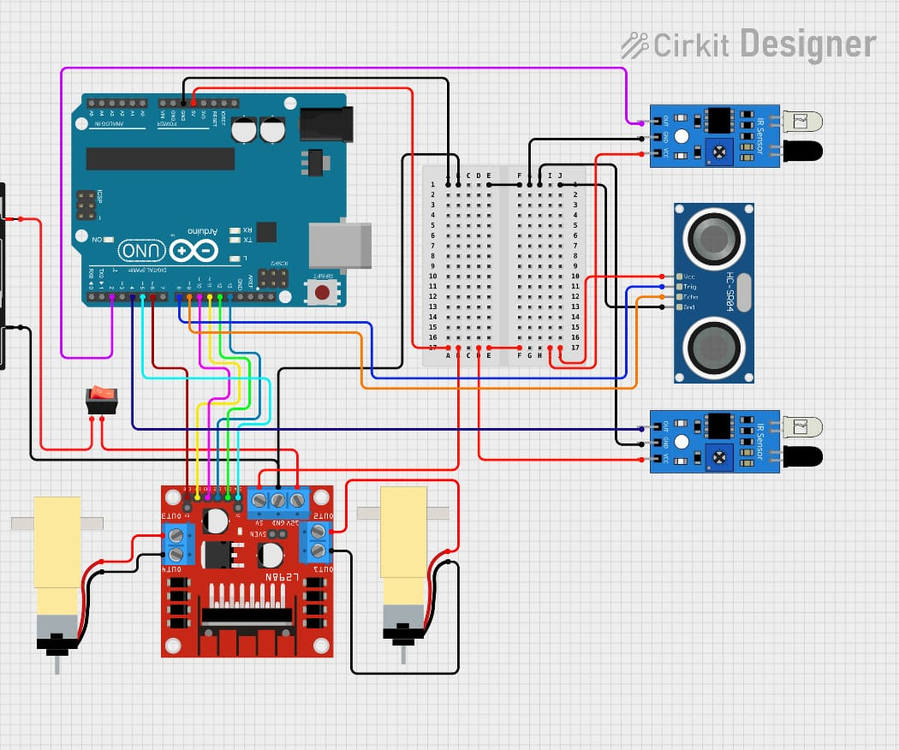

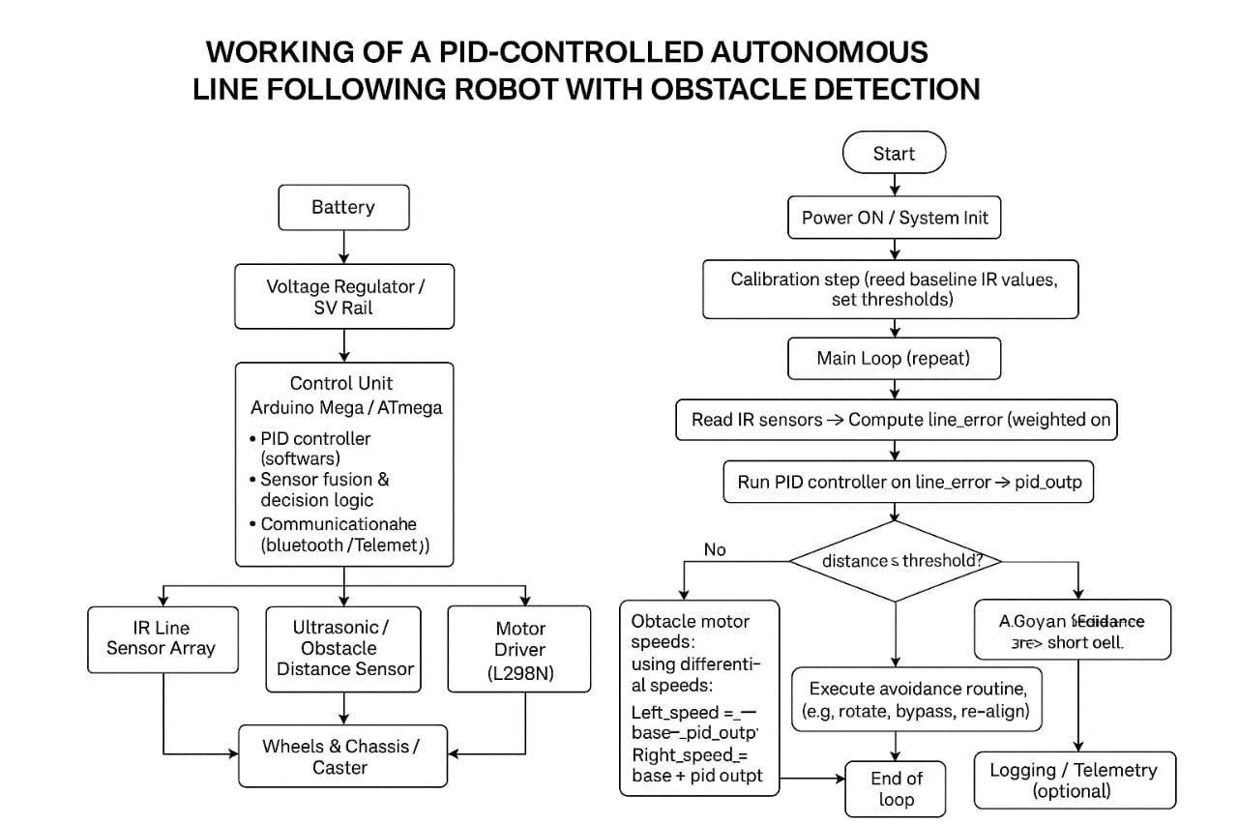
Working of the PID-Controlled Autonomous Bot with Obstacle Detection
The robot follows a predefined path using an IR sensor array placed at its front. These sensors detect the contrast between the black line and the surrounding surface. Based on the sensor readings, the robot calculates an error value that represents how far it has deviated from the center of the line. This error is fed into a PID (Proportional–Integral–Derivative) controller, which continuously adjusts the speeds of the left and right motors. By increasing the speed of one motor and decreasing the other, the robot smoothly corrects its direction and accurately stays on the track, even around curves.
While the PID system handles line following, the robot also uses an ultrasonic sensor for obstacle detection. The sensor measures the distance to objects in front of the bot. If an obstacle is detected within a preset safe distance, the bot immediately stops to avoid collision. Depending on the programmed logic, it may pause, take a detour, or wait until the obstacle is removed. Once the path becomes clear, the robot resumes normal PID-based line following. Through continuous sensor feedback, real-time PID control, and active obstacle detection, the robot achieves smooth, stable, and safe autonomous navigation.

Project Summary
This project presents a PID-controlled autonomous line-following robot with an integrated obstacle detection system. The robot uses an IR sensor array to track a predefined line and a PID algorithm to correct deviations by adjusting motor speeds smoothly and accurately. An ultrasonic sensor continuously monitors the path for obstacles, enabling the robot to stop or bypass objects in real time. The system is built using an Arduino Mega, an L298N motor driver, DC motors, and a 7.4V battery supply. Through the combination of intelligent sensing, adaptive control, and safe navigation, the robot demonstrates a practical solution for smart mobility, automated transport, and modern urban infrastructure applications.
Conclusion
The developed robot successfully follows a line with high stability using PID control while reliably detecting and responding to obstacles. The integration of sensor inputs with real-time decision-making allows the bot to navigate safely in dynamic environments. The project highlights how simple, low-cost hardware combined with intelligent algorithms can create an efficient autonomous system suitable for smart city applications. Overall, the prototype proves that autonomous robots can enhance operational efficiency, reduce human effort, and support safer, smarter, and more sustainable urban mobility.

Sl no | Topics
1 | Abstract
2 | Introduction
3 | List of components
4 | Circuit diagram
5 | Working
6 | Implementation
7 | Project summary
8 | Conclusion

Implementation (Short & Brief)

The autonomous line-following robot was implemented through coordinated hardware–software integration. The chassis houses two DC geared motors, an IR sensor array, an ultrasonic sensor, the Arduino Mega controller, and the L298N motor driver. A 7.4V Li-ion battery powers the motors, while a 5V regulated supply powers the controller and sensors. All grounds are connected to ensure stable operation.

The IR sensor array is interfaced with the Arduino to detect the black line, while the ultrasonic sensor provides obstacle distance measurements. The motor driver receives PWM and direction signals from the Arduino to control speed and movement.

In software, the robot continuously reads line sensor values, calculates the line position error, and applies a PID control algorithm to adjust left and right motor speeds for smooth and accurate tracking. Simultaneously, the ultrasonic sensor monitors for obstacles. If an object is detected within a preset threshold, the robot stops and performs an avoidance action before returning to the line.

